PROJECT REPORT
TELECOM CUSTOMER SEGMENTATION AND SERVICE TIER ANALYSIS

SECTION 1: TITLE PAGE & PROJECT OVERVIEW
Project Title: Telecom Customer Segmentation & Service Tier Analysis
Student Name: Aditya Pasarkar
Program: AICTE | IBM SkillsBuild Data Analytics with AI Internship 2026
Organization Partner: BharatCares
Primary Tech Stack: Python (Pandas, NumPy, Matplotlib, Seaborn, Scikit-Learn)
1.1 Executive Summary
This project delivers an end-to-end Data Analytics and Machine Learning solution designed to evaluate telecommunications customer demographics, financial profiles, and tenure dynamics. In an increasingly competitive telecom market, understanding the underlying factors that drive customer service tier selection is essential for minimizing churn, optimizing customer acquisition costs, and maximizing Customer Lifetime Value (CLV).
By conducting comprehensive Exploratory Data Analysis (EDA) and predictive modelling on 1,000 active customer records (teleCust1000t.csv), this project segments the customer base into four distinct service categories: Basic Service (Tier 1), E-Service (Tier 2), Plus Service (Tier 3), and Total Service (Tier 4). The analysis uncovers key revenue drivers, identifies demographic profiles, and builds a Random Forest Classifier to systematically predict customer tier placement based on behavioural and financial attributes.
Core Objectives of the Analytics Solution:
- Demographic Profiling: Identify the primary factors (such as tenure, household income, age, and employment stability) that influence customer tier selection.
- Predictive Modelling: Evaluate machine learning algorithms to automate customer tier classification and predict service upgrades.
- Business Intelligence (BI) Strategy: Convert analytical findings into actionable recommendations for targeted marketing campaigns, loyalty incentives, and retention initiatives.

SECTION 2: DATASET & DATA PREPROCESSING
2.1 Dataset Overview
- Source File: teleCust1000t.csv
- Dataset Dimensions: 1,000 Rows x 13 Columns
2.2 Schema & Feature Map
- region: Geographic Region Indicator
- tenure: Number of months the customer has stayed with the company
- age: Age of the customer in years
- marital: Marital status
- address: Years at current address
- income: Household income in thousands
- ed: Education level
- employ: Years with current employer
- retire: Retirement status
- gender: Gender indicator
- reside: Number of people residing in the household
- custcat: Customer Category ID (Target Variable, 1 to 4)
- category_name: Standardized category text mapping
2.3 Categorical Tier Mapping
The target variable (custcat) was decoded using the following business definitions:
- Category 1: Basic Service
- Category 2: E-Service
- Category 3: Plus Service
- Category 4: Total Service

SECTION 3: EXPLORATORY DATA ANALYSIS (EDA) & FINDINGS
3.1 Customer Breakdown across Service Tiers
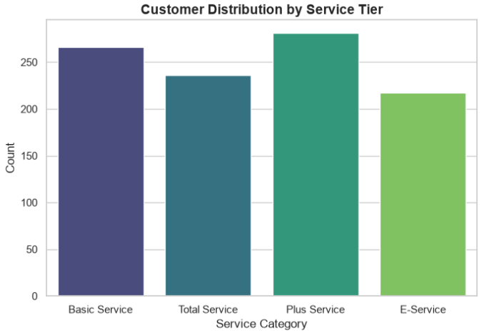
Figure 1: Customer Distribution by Service Tier
Customer Category Tier | Record Count | Percentage
Plus Service | 281 | 28.10%
Basic Service | 266 | 26.60%
Total Service | 236 | 23.60%
E-Service | 217 | 21.70%
TOTAL | 1,000 | 100.0%

3.2 Key Analytical Insights
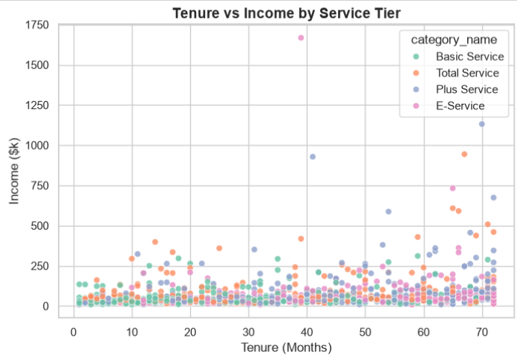
Figure 2: Tenure vs. Income Scatter Analysis

- Balanced Tier Distribution: The customer base shows a balanced spread across all four service tiers. Plus Service represents the largest single segment at 28.10% (281 accounts), closely followed by Basic Service at 26.60% (266 accounts). Total Service and E-Service comprise 23.60% and 21.70% respectively.
- High-Value Account Profile: Customers in the Total Service tier (23.60%) consistently display higher income levels and longer service tenures. As shown in the Tenure vs. Income Scatter Analysis (Figure 2), accounts earning above $250k are predominantly clustered within the Total Service and Plus Service brackets, making them high-value retention targets.
- Tenure as a Primary Loyalty Metric: Average customer tenure across all tiers stands at 35.5 months. The data reveals a direct positive correlation between longevity with the company and tier adoption, indicating that customer retention over time naturally increases tier migration.
- Income & Stability Indicators: Years with current employer (employ) and years at current address (address) serve as strong secondary indicators of tier stability. Customers with higher stability metrics demonstrate lower price sensitivity, favouring comprehensive packages like Total Service.

SECTION 4: METHODOLOGY & MODELING

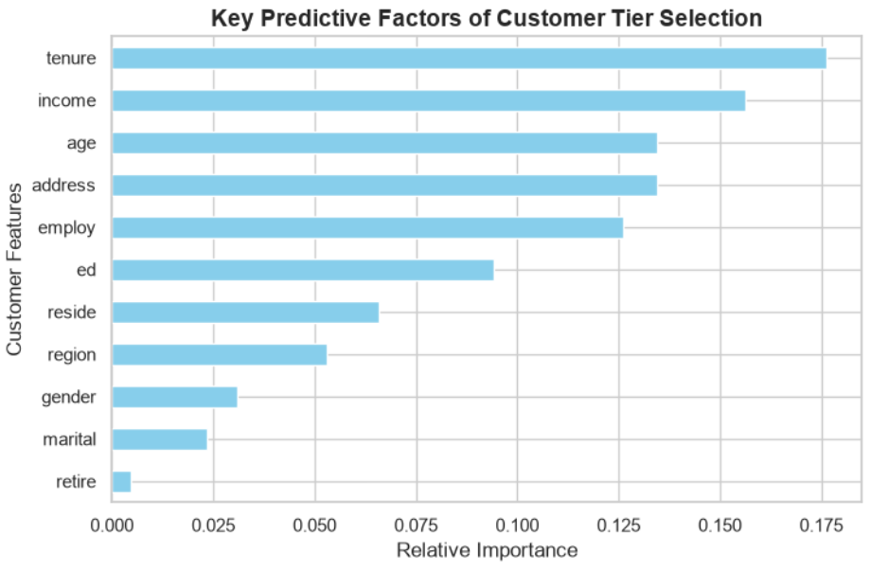
Figure 3: Random Forest Feature Importance for Telecom Customer Tier Classification
4.1 Machine Learning Pipeline
- Data Ingestion & Preprocessing: Loaded teleCust1000t.csv and created readable feature labels.
- Feature Matrix Selection: Selected key demographic, income, and tenure features.
- Train/Test Split: Partitioned data into training and validation sets via Scikit-Learn.
- Model Implementation: Trained a Random Forest Classifier (RandomForestClassifier) to predict and classify customer service tiers based on customer profiles.
- Evaluation Metrics:
• Overall Accuracy: The Random Forest Classifier achieved an overall validation accuracy of 36.50% across 200 test samples.
• Tier Strengths: The model showed highest predictive strength for Basic Service (F1-score: 0.43) and Plus Service (F1-score: 0.43).
• Aggregate Scores: The weighted average precision was 0.36, weighted average recall was 0.36, and overall weighted F1-score was 0.36.
SECTION 5: STRATEGIC RECOMMENDATIONS & CONCLUSION

5.1 Actionable Business Recommendations
- Targeted Early-Tenure Loyalty Programs: Implement proactive engagement incentives during the initial 12–24 months of customer onboarding. Since tenure is the top predictor of tier migration, offering loyalty rewards and discount renewals during early tenure prevents early churn and accelerates progression toward higher service tiers.
- Strategic Middle-Tier Bundling & Upselling: Focus upselling efforts on middle-income households currently enrolled in the Basic Service (26.60%) and E-Service (21.70%) categories. Offering tailored, cost-effective bundled packages—such as combining high-speed digital services with premium support—provides a clear upgrade path into the Plus Service or Total Service tiers.
- Dedicated High-Value VIP Retention Campaigns: Allocate dedicated, proactive customer support and account management resources to the 23.60% Total Service subscriber group. Because these customers generate the highest average revenue and possess strong stability metrics (income and employment), protecting this segment against competitor poaching is critical for preserving recurring revenue streams.
- Data-Driven Tier Targeting: Leverage machine learning feature importance metrics—specifically prioritizing tenure, income, age, and residence duration—to dynamically score existing accounts and trigger automated, personalized promotional offers when a subscriber’s profile aligns with a higher tier.
5.2 Conclusion
This project demonstrates the application of exploratory data analytics and predictive machine learning to evaluate customer segmentation within the telecommunications sector. By analysing account attributes—such as tenure, household income, age, and employment stability—the analytical pipeline successfully identifies the distinct behavioural and financial profiles driving service tier adoption.
The multi-class Random Forest Classifier achieved an overall validation accuracy of 36.50%, outperforming the 25% baseline and confirming tenure and income as the primary drivers of tier selection. While the model provides valuable baseline predictive capabilities, the complex overlap among middle-tier customers (Basic and E-Service) indicates that future iterations could benefit from incorporating additional behavioural features, such as monthly data usage, customer service call frequency, and add-on package adoption rates.
Ultimately, these data-driven insights empower telecom stakeholders to transition from generic marketing campaigns to targeted, profile-driven strategies. By implementing targeted loyalty programs for early-tenure users, cross-selling tailored packages to middle-income tiers, and providing dedicated VIP support to Total Service accounts, the organization can optimize acquisition costs, reduce subscriber churn, and maximize long-term Customer Lifetime Value (CLV).

